- What is assembly level language? Give an example.
The low level language that uses mnemonic instructions to represent machine code instructions. For example, the mnemonic 'MOV' stands for 'move' and is used to move data from one location to another.
MOV A,B
- Why do we need assembly level language?
Machine language code consists of the 0-1 combinations that the computer decodes directly. However, the machine language has the following problems:
- It greatly depends on machine and is difficult for most people to write in 0-1forms. .
- Debugging is difficult.
- Deciphering the machine code is very difficult. Thus, program logic will be difficult to understand.

To overcome these difficulties computer manufacturers have devised English-like words to represent the binary instruction of a machine. This symbolic code for each instruction is called a mnemonic. The mnemonic for a particular instruction consists of letters that suggest the operation to be performed by that instruction. For example, ADD mnemonic is used for adding two numbers. Using these mnemonics machine language instructions can be written in symbolic form with each machine instruction represented by one equivalent symbolic instruction. This is called an assembly language.

- Pros and Cons of Assembly Language

The following are some of the advantages1disadvantages of using assembly language:
Assembly Language provides more control over handling particular hardware and software, as it allows you to study the instructions set, addressing modes, interrupts etc.
Assembly Programming generates smaller, more compact executable modules: as the programs are closer to machine, we may be able to write highly optimized programs. This results in faster execution of programs.
Assembly language programs are at least 30% denser than the same programs written in high-level language. The reason for this is that as of today the compilers produce a long list of code for every instruction as compared to assembly language, which produces single line of code for a single instruction. This will be true especially in case of string related programs.

On the other hand, assembly language is machine dependent. Each microprocessor has its own set of instructions. Thus, assembly programs are not portable.
Assembly language has very few restrictions or rules; nearly everything is left to the discretion of the programmer. This gives lots of freedom to programmers in construction of their system.

- Uses of Assembly Language
Assembly language is used primarily for writing short, specific, efficient interfacing modules/ subroutines. The basic idea of using assembly is to support the HLL with some highly efficient but mn-portable routines. It will be worth mentioning here that UNIX mostly is written in C but has about 5-10% machine dependent assembly code. Similarly in telecommunication application assembly routine exists for enhancing efficiency.
- ASSEMBLY PROGRAM EXECUTION
An assembly program is written according to a strict set of rules. An editor or word processor is used for writing an assembly program into the computer as a file as .asm ALP and then the assembler is used to translate the program into .obj machine code. After that Linker links the machine code with other necessary library files to convert into .exe machine code.
There are 2-ways of converting an assembly language program into .obj machine language:
- Manual Assembly
- Using an Assembler

- Manual Assembly
It was an old method that required the programmer to translate each opcode into its numerical machine language representation by looking up a table of the microprocessor instructions set.
The Intel SDK-85 and most of the earlier university were programmed using manual assembly.

- Using an Assembler
The symbolic instructions that you code in assembly language is known as - Source program.
An assembler program translates the source program into machine code, which is known as object program.
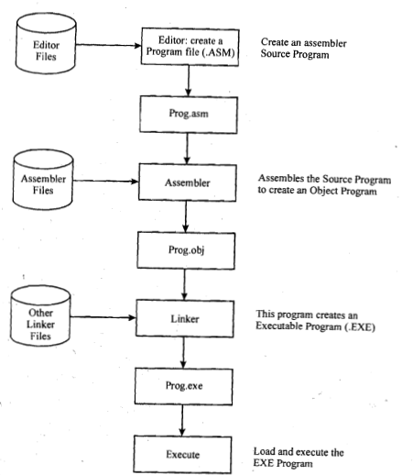
Fig: Program Assembly
The execution of Assembly Level Programs requires assemble, link and execute a program are:

Step 1: The assembly step involves translating the source code into object code and generating an intermediate .OBJ (object file) or module. The .OBJ module is not quite in executable form.

All this conversion and execution of Assembly language performed by Two-pass assembler.
Two-pass assembler: Assemblers typically make two or more passes through a source program in order to resolve forward references in a program. A forward reference is defined as a type of instruction in the code segment that is referencing the label of an instruction, but the assembler has not yet encountered the definition of that instruction.
\
Pass 1: Assembler reads the entire source program and constructs a symbol table of names and labels used in the program, that is, name of data fields and programs labels and their relative location (offset) within the segment.

Pass 2: The assembler uses the symbol table that it constructed in Pass 1. Now it krnows the length and relative position of each data field and instruction, it can complete the object code for each instruction. It produces .OBJ (Object file), .LST (list file) and cross reference (.CRF) files.

Step 2: The link step involves converting the .OBJ module to an .EXE machine code module.
The linker combines assembled module into one executable program /'generates an .EXE module and initializes with special instructions to facilitate its subsequent loading for execution.

Step 3: The last step is to load the program for execution. Because the loader knows where the program is going to load in memory, it is now able to resolve any remaining address still left incomplete in the .EXE file

6. Tools required for assembly language programming
The tools of the assembly process described below may vary in details.

Editor
It is a program which is used to construct the assembly language program in correct format so that the Assembler will translate it correctly to machine language.
An Editor is a program which allows us to create a file containing the assembly language statement for the program. If any typing mistake is done editor will alert Us to correct it. If we leave out a program statement an editor will let you move everything down and insert a line.
After typing all the program, we have to save the program for a hard disk. This we call it as source file.
Ex: Sample.asm Editors are EDIT, Word Star, Norton Edit
Assembler
An Assembler is used to translate the assembly language mnemonics into machine language (i.e. binary codes). When you run the assembler, it reads the source file of your program from where you have saved it. The assembler generates two files The first file is the Object file with the extension .OBJ. The object file consists of the binary codes for the instructions and information about the addresses of the instructions. After further processing, the contents of the file will be loaded in to memory and run. The second file is the assembler list file, with the extension. LST: Assemblers are TASM(Borland's Turbo Assembler) MASM(Microsoft. Macro Assembler).
Linker
For modularity of your programs, it is better to break your program into several sub routines. It is even better to put the common routine, like reading a hexadecimal number, writinghexadecimal number, etc., which could be used by a lot of your other programs into a separate file. These files are assembled separately. After each file has been successfully assembled, they can be linked together to form a large file, which constitutes your complete program. The file containing the common routines can be linked to your other program also. The program that links your program is called the linker.

Loader
Loader comes into action when you want to execute your program. This program is brought from the secondary memory like disk. The file name extension for loading is .exe or .com, which after loading can be executed by the CPU.

Debugger
The debugger is a program that allows the user to test and debug the object file. The user can employ this program to perform the following functions.
- Make changes in the object code.
- Examine and modify the contents of memory.
- Set breakpoints, execute a segment of the program and display register contents after the execution.
- Trace the execution of the specified segment of the program and display the register and memory contents after the execution of each instruction.

- Differences between one pass and two pass assemblers
